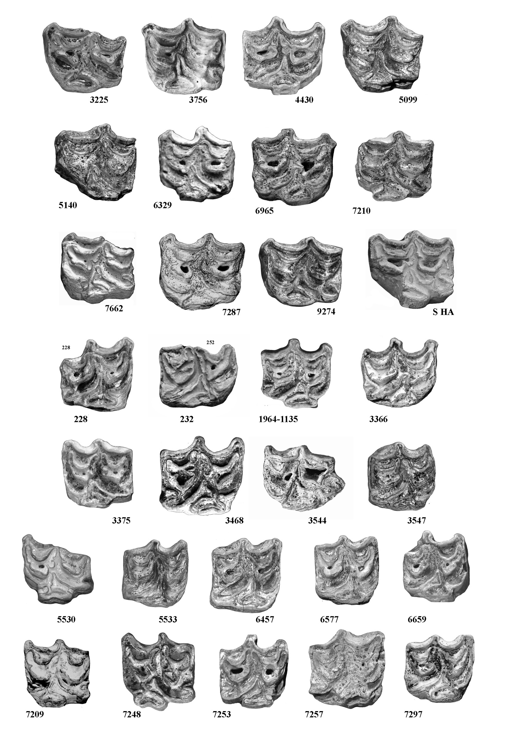

Figure S18. Occlusal views of upper cheek teeth of *E. marxi*. All the accession numbers should be prefixed by IQW S. IQW S 3225 to S HA: Premolars. IQW S 228 to 7297: Molars.